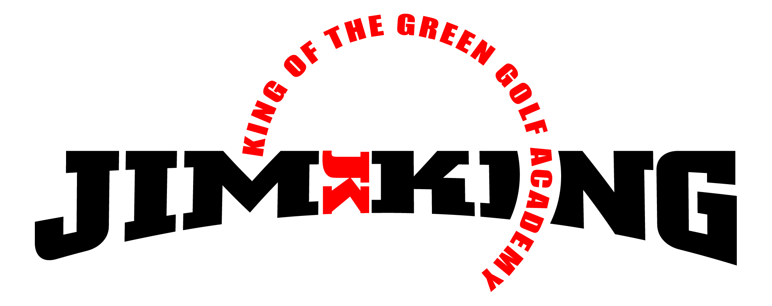
PGA GOLF INSTRUCTION

May 2019

Dear Lansbrook Golfers:
Mother’s Day Special! King of the Green Golf Academy is offering a Private 5-Lesson Package for $225, a savings of $75 and a Private 3-Lesson Package for $150, a savings of $30. Each lesson will be about one hour and cover all aspects of the game, may include high speed video analysis of your golf swing and on-course play. This private golf lesson package will make the perfect Mother’s Day gift and you will be provided with a personalized themed gift certificate for your presentation as well.
2019 King of the Green Summer Junior Golf Camp begins Monday June 3th. Junior golfers ages 6-17, beginners or advanced players will benefit from Golf Camp. Our goals for the junior golfers are to meet new friends, have fun and learn about the great game of golf. Golf clubs will be provided if needed. Includes PGA instruction in all aspects of the game: grip, stance, full-swing, pitching, chipping, bunker play, putting, rules & etiquette and on-course play.
JUNE Camp Weeks: 3-6, 10-13, 17-20, 24-27.
- Day/Time: Monday-Thursday, 10 am until noon each day.
- Cost: $80 per week, prorated daily $20. Participate one day or all four days.
Below is my Weekly Golf Clinic schedule for Adults and Juniors. Group Golf Clinics offer a relaxed atmosphere, learning can be enhanced, group dynamic is stimulating, they are cost efficient and for many it is more enjoyable learning golf with others. Also, feel free to invite family, friends, neighbors or work associates to join you.

Good Golfing,
Dana Saad, PGA Director of Instruction
Contact me: 813-205-5143 or danasaad@aol.com
Lansbrook Golf Club
Dana Saad’s Weekly PGA Golf Clinic Schedule

LANSBROOK PLAYER DEVELOPMENT PROGRAM (PDP)
- Sunday 10:00 -11:00 am: Mastering the fundamentals of golf. Full swing, Putting, Chipping & Pitching and Bunker play. Free for PDP members, $15 for non-PDP members.

JUNIOR GOLFERS
- Wednesday 4:30 - 5:30 pm & Saturday 12:00 - 1:00 pm: Enroll your child for “the game of a life time”. Instruction in all aspects of the game of golf. Ages 6 – 17, $15 per junior golfer per clinic.

ADULT GOLFERS – “PGA Get Golf Ready”
- Thursday 4:30 - 5:30 & Friday 10:00 - 11:00 am: A PGA of America endorsed program! Lansbrook is an authorized PGA host “Get Golf Ready” facility. The perfect golf clinic for active players, those who want to play more golf, and also for new golfers who are just getting started. Only $15 per clinic. Visit www.getgolfready.com to learn more.

