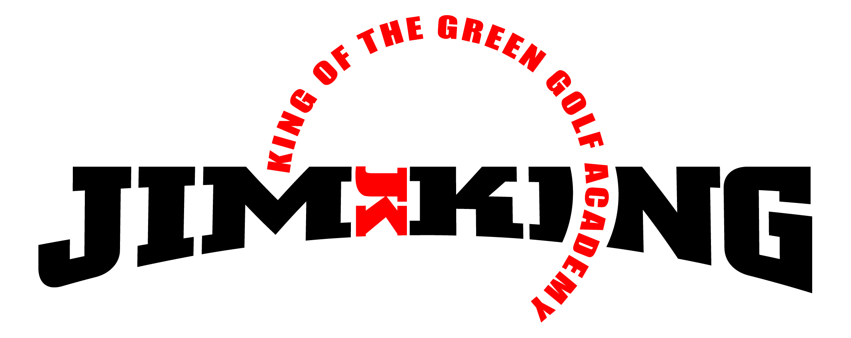

Northdale Golf Club
On Course Playing Lessons Available
Take Your Game to the Course!!!

May 2019
PGA 2-Hour on Course Playing Lesson. Instruction in all aspects of the game: grip, stance, full-swing, pitching, chipping, bunker play, putting, course management, rules & etiquette. And most important…how to have fun! Golfers of all skill levels welcome.
- Time: Weekday mornings by appointment.
- Cost: $100- 1 player, $80- 2 players, $60- 3 players.
Contact me to sign-up or ask any questions.

Good Golfing,

Dana Saad, PGA Director of Instruction
Contact me: 813-205-5143 or danasaad@aol.com

